Minutes of the 24th meeting of TC 21 “Mathematical modeling of glass melting processes” in Velke Karlovice, Czech Republic, 19th of May,2005

Agenda;

- Discussion of the combined model (RRT 4a) results
- Possible future subjects for a new round robin test
- Date and place of next meeting

Notes from the meeting;

1. Definitions for RRT 4a had been finalized during the meeting in Yalos, Athens 2004.
RRT 4a results from the final studies have been discussed in the meeting. Glass Service and
Sisecam presented their results along with evaluations on the final outcomes.

The discussion on the approaches and results were overviewed with respect to the heat balances, temperature and velocity profiles and minimum residence time values of the furnace at 25 t/d and 40 t/d.

With the specified new pull rates; corresponding fuel consumption and relevant burner diameters are used. An initial batch length of 2.3 m for 25 t/d and 3.7 m for 40 t/d is assumed. Glass density is taken as a function of temperature. Evaporation of gases from the batch blanket is not considered and emissivity of batch blanket is kept as 0.9. A new equation is used for thermal conductivity of batch for the 300-1473 K temperature region.

The results from Sisecam for RRT 4a are given below. The presentation and results of Glass Service will also be included into the minutes when received and a revised version of the minutes will be sent. The effects of new conditions were discussed. There are some discrepancies in glass temperatures and minimum residence time values in the results of Glass Service, Sisecam and Schott. The relation between different pull rates can be driven reasonably within each study. Upon increasing the pull rate to 40 t/d with the relevant increase of fuel rate, the expected decrease in minimum residence time and temperatures in the glass bath could be observed.

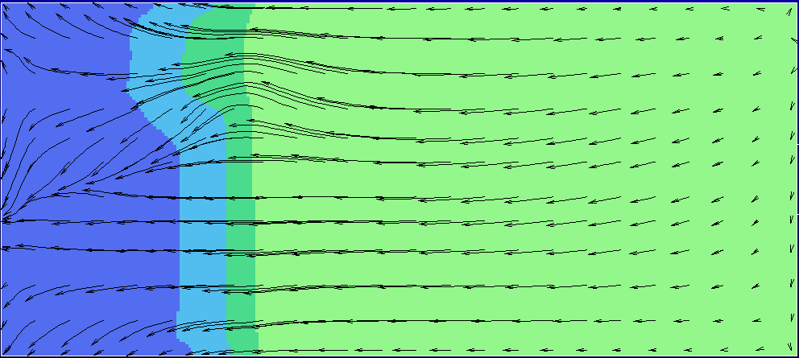
RRT 4a; 25t/d
1.92 m/ 2.3 m

RRT 4a; 40t/g

3.66 m/ 3.70 m

725 1175 1225 1275 1325 1375 1425 1475 1525 1575 1625 C

Figure 1. Top view from the glass surface for temperature distribution, velocity profile and
final batch lengths from RRT 4a results for 25 t/d and 40 t/d with
respective initial batch lengths of 2.3 m and 3.7 m.

Table 1. Results for RRT 4a
 | 25 t/d | 40 t/d
Final batch length | 1.92 m | 3.66 m
1 % of particles exiting throat | 8.2 hr | 3.2 hr
Glass temperature at the throat | 1260 C | 1220 C

Effect of glass density taken as a function of temperature;
Taking glass density as a function of temperature in the glass bath does not have much effect on general flow patterns but glass temperature at the throat increases by 8 C in the 25 t/d pull rate case.

Effect of buoyancy in the furnace atmosphere;
Effect of buoyancy was discussed in the previous meeting and the subject was taken up again during this meeting.

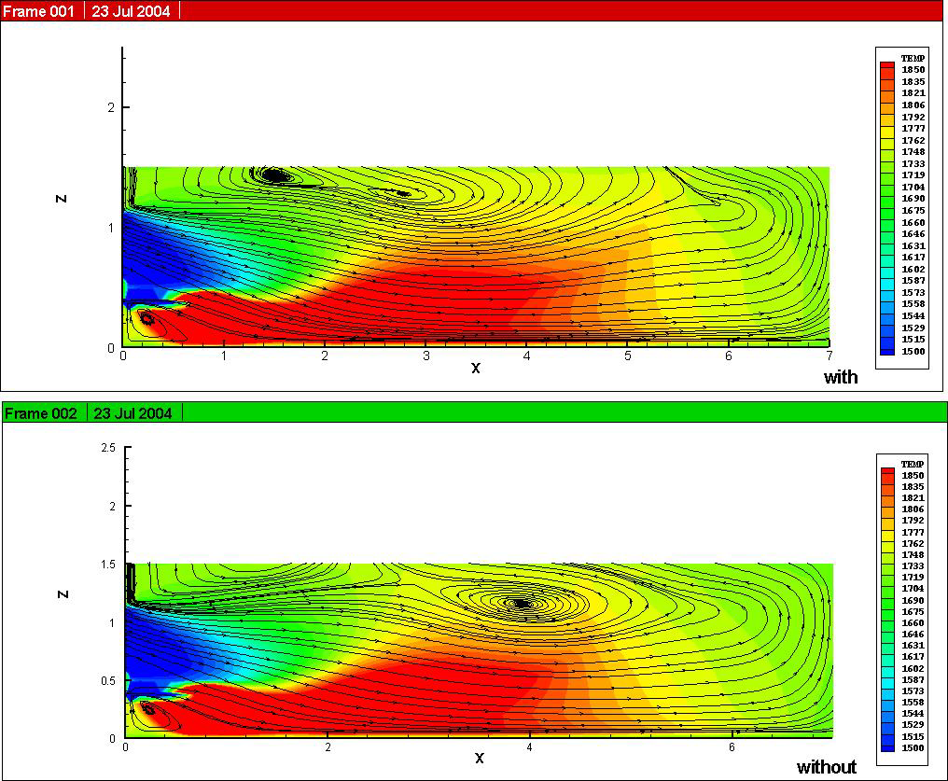
a)

b)

Figure 2 . Effect of buoyancy term in the furnace atmosphere;
a) with buoyancy and
b) without buoyancy for 25 t/d pull rate.

The total amount of heat transferred into glass bath is
  - 835 kW without the buoyancy effect and
  - 846 kW with the buoyancy effect taken into account both in the turbulence equations and in the z-direction momentum equation.

~1.3 % of difference could be seen in the amount of energy transferred into glass and the flame length is 0.3-0.4 m longer with buoyancy. The application of buoyancy term in a high capacity container furnace again results in a 1% increase in the energy transferred into glass bath.

2. a) Future subjects that might be studied within the scope of TC 21 have been discussed during the meeting and it is agreed to make suggestions on both new round robin tests that could be studied in TC 21 and also bring up new topics for discussion during the meetings. It was decided in the meeting to collect ideas and proposals for new round robin tests and topics for discussion. I would like to thank colleagues who have already sent their proposals.

b) Joint studies of TC 21 with other technical committees have been carried out with TC 18 on high temperature effective thermal conductivity and thermal expansion coefficient of glass. Results have been shared. Sensitivity analyses of some other key properties of glass at high temperatures could continue with TC 18.

3. It was agreed to plan the date and place of the next meeting by the beginning of
September, 2005 after the collection of results on RRT 4-4a and proposals for new subjects.

